**EXPERIMENT 01**

CLASS: BE CMPN A ROLL NO. : 19

NAME: REBECCA DIAS PID: 182027

Aim: Case study on DSP and IP and its applications

Theory:

* What is meant by signal?

A signal is an electric current or electromagnetic field used to convey data from one place to another. The simplest form of signal is a direct current (DC) that is switched on and off; this is the principle by which the early telegraph worked. More complex signals consist of an alternating-current (AC) or electromagnetic carrier that contains one or more data streams.

Data is superimposed on a carrier current or wave by means of a process called modulation. Signal modulation can be done in either of two main ways: analog and digital. In recent years, digital modulation has been getting more common, while analog modulation methods have been used less and less. There are still plenty of analog signals around, however, and they will probably never become totally extinct.

Except for DC signals such as telegraph and baseband, all signal carriers have a definable frequency or frequencies. Signals also have a property called wavelength, which is inversely proportional to the frequency.

* What are types of signals?

Three main types of signals encountered in practice are analog ,digital and discrete. A digital signal that results from approximating an analog signal by its values at particular time instants. Digital signals are quantized, while analog signals are continuous.

1. Analog Signal

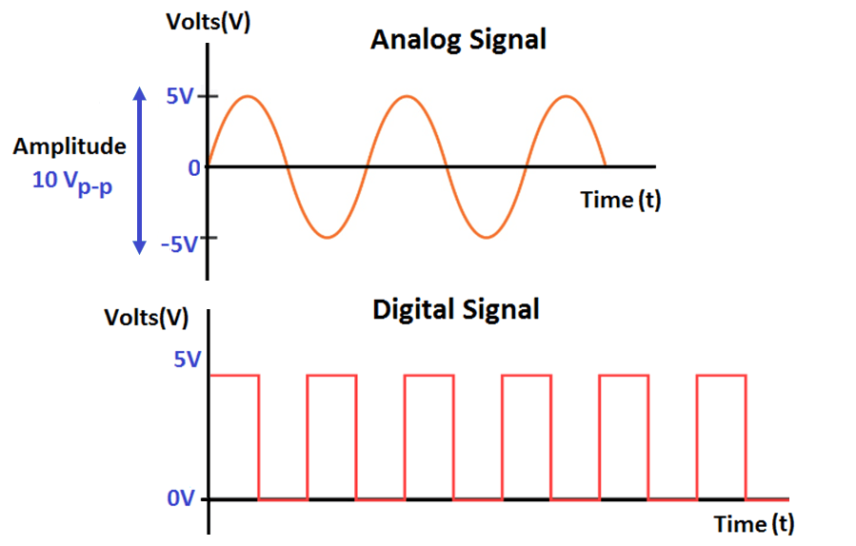

1. An analog signal is one type of continuous time-varying signals, and these are classified into composite and simple signals.
2. A simple type of analog signal is nothing but a sine wave, and that can’t be decomposed, whereas a composite type analog signal can be decomposed into numerous sine waves.
3. An analog signal can be defined by using amplitude, time period otherwise frequency, & phase. Amplitude streaks the highest height of the signal, frequency streaks the rate at which an analog signal is varying, and phase streaks the signal position with respect to time nothing.
4. An analog signal is not resistant toward the noise, therefore; it faces distortion as well as reduces the transmission quality. The analog signal value range cannot be fixed.
5. Discrete Signal

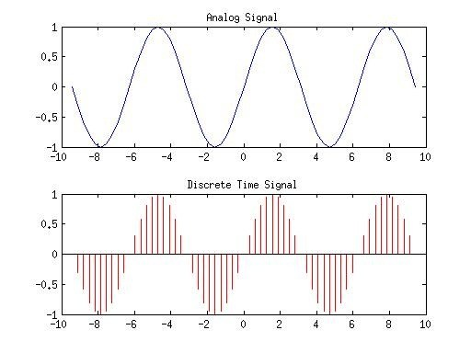

1. A discrete-time signal (sometimes referred to as a time-discrete signal or simply a discrete signal) is shown in Figure 15(b).
2. In the rest of this course the standard convention of drawing the vertical lines in a discrete-time signal with a round dot on the end will be used; these lines-with-dots are often called ‘lollipops’. The signal in Figure 15(b) is discrete because it only has a value at fixed points placed at discrete time intervals seconds apart along the -axis. is called the sampling interval.
3. Values of can be found for the integer values of , such as , , etc., but there is no value for the signal at, say, . Thus represents the number of the sample.
4. Example: the temperature reading of a room every day at the same time, the result would be a discrete-time signal. Most discrete-time signals come from sampling continuous-time signals to get them into a digitised form that can be processed by digital computers.
5. Digital Signal

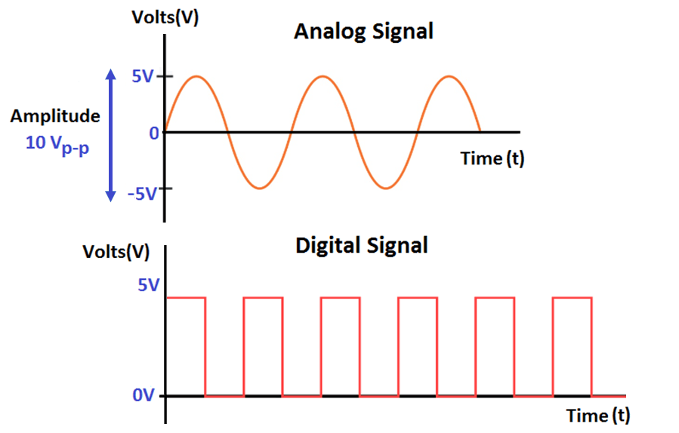

1. A digital signal carries the data in the form of binary because it signifies in the bits.

These signals can be decomposed into sine waves which are termed as harmonics.

1. Every digital signal has amplitude, frequency, & phase like the analog signal. This signal can be defined by bit interval as well as bit rate. Here, bit interval in nothing but the required time for transmitting an only bit, whereas the bit rate is bit interval frequency.
2. Digital signals are more resistant toward the noise; therefore, it barely faces some distortion. These waves are simple in transmitting as well as more dependable while contrasted to analog waves.
3. Digital signals include a limited variety of values which lies among 0-to-1

* What is meant by DSP?

Digital signal processing (DSP) is the use of digital processing, such as by computers or more specialized digital signal processors, to perform a wide variety of signal processing operations. The digital signals processed in this manner are a sequence of numbers that represent samples of a continuous variable in a domain such as time, space, or frequency. In digital electronics, a digital signal is represented as a pulse train, which is typically generated by the switching of a transistor.

* Explain block diagram of DSP.

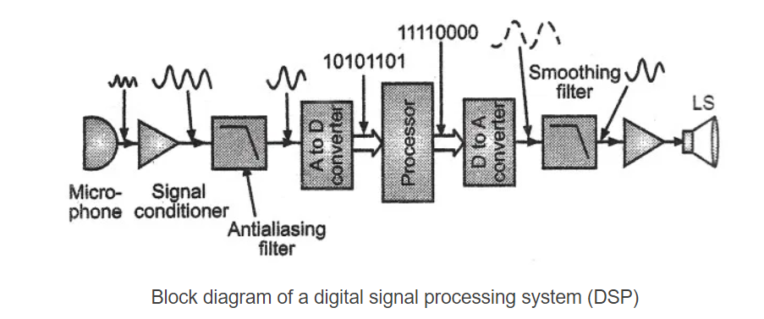

1. The first step is to get an electrical signal. The transducer (in our case, a microphone) converts sound into an electrical signal. You can use any transducer depending upon the case.
2. Once you have an analog electrical signal, we pass it through an operational amplifier (Op-Amp) to condition the analog signal. Basically, we amplify the signal. Or limit it to protect the next stages.
3. The anti-aliasing filter is an essential step in the conversion of analog to a digital signal. It is a low-pass filter. Meaning, it allows frequencies up to a certain threshold to pass. It attenuates all frequencies above this threshold. These unwanted frequencies make it difficult to sample an analog signal.
4. The next stage is a simple analog-to-digital converter (ADC). This unit takes in analog signals and outputs a stream of binary digits.
5. The heart of the system is the digital signal processor. These days we use CMOS chips (even ULSI) to make digital signal processors. In fact, modern processors, like the Cortex M4 have DSP units built inside the SoC. These processor units have high-speed, high data throughputs, and dedicated instruction sets.
6. The next stages are sort of the opposite of the stages preceding the digital signal processor.
7. The digital-to-analog converter does what its name implies. It’s necessary for the slew rate of the DAC to match the acquisition rate of the ADC.
8. The smoothing filter is another low-pass filter that smoothes the output by removing unwanted high-frequency components.
9. The last op-amp is just an amplifier.
10. The output transducer is a speaker in our case. You can use anything else according to your requirements.

* List different modern DSPs.

Modern signal processors yield greater performance; this is due in part to both technological and architectural advancements like lower design rules, fast-access two-level cache, (E)DMA circuitry and a wider bus system.

i. Texas Instruments produces the C6000 series DSPs, which have clock speeds of 1.2 GHz and implement separate instruction and data caches.

ii. Freescale produces a multi-core DSP family, the MSC81xx. The MSC81xx is based on StarCore Architecture processors and the latest MSC8144 DSP combines four programmable SC3400 StarCore DSP cores. Each SC3400 StarCore DSP core has a clock speed of 1 GHz.

iii. XMOS produces a multi-core multi-threaded line of processor well suited to DSP operations, They come in various speeds ranging from 400 to 1600 MIPS. The processors have a multi-threaded architecture that allows up to 8 real-time threads per core, meaning that a 4 core device would support up to 32 real time threads.

iv. CEVA, Inc. produces and licenses three distinct families of DSPs. Perhaps the best known and most widely deployed is the CEVA-TeakLite DSP family, a classic memory-based architecture, with 16-bit or 32-bit word-widths and single or dual MACs.

1. NXP Semiconductors produce DSPs based on TriMedia VLIW technology, optimized for audio and video processing. In some products the DSP core is hidden as a fixed-function block into a SoC, but NXP also provides a range of flexible single core media processors.

* Comparisons between DSPs and Microprocessors

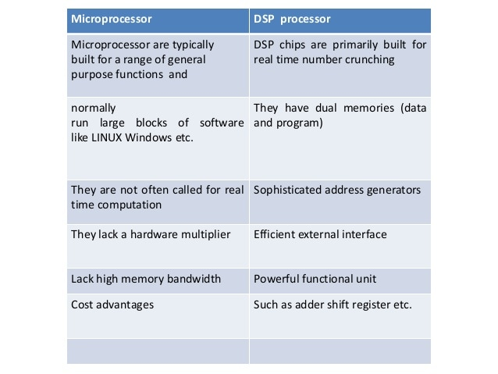

* Differenciate between Analog Signal Processing and Digital Signa Processing

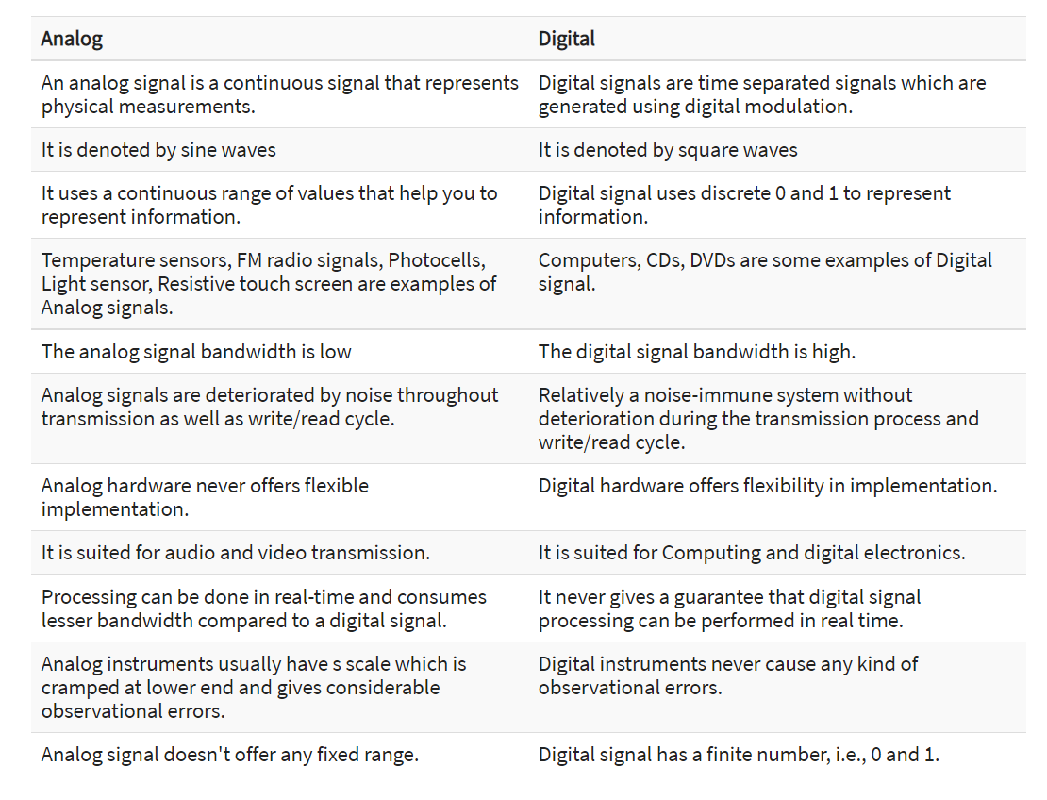

* Real applications of DSP

1. Audio signal processing
2. [Audio data compression](https://en.wikipedia.org/wiki/Audio_data_compression) e.g. [MP3](https://en.wikipedia.org/wiki/MP3)
3. [Video data compression](https://en.wikipedia.org/wiki/Video_data_compression)
4. [Computer graphics](https://en.wikipedia.org/wiki/Computer_graphics)
5. [Digital image processing](https://en.wikipedia.org/wiki/Digital_image_processing)
6. [Photo manipulation](https://en.wikipedia.org/wiki/Photo_manipulation)
7. [Speech processing](https://en.wikipedia.org/wiki/Speech_processing)
8. [Speech recognition](https://en.wikipedia.org/wiki/Speech_recognition)
9. [Data transmission](https://en.wikipedia.org/wiki/Data_transmission)
10. [Radar](https://en.wikipedia.org/wiki/Radar)
11. [Sonar](https://en.wikipedia.org/wiki/Sonar)
12. [Financial signal processing](https://en.wikipedia.org/wiki/Financial_signal_processing)
13. [Economic forecasting](https://en.wikipedia.org/wiki/Economic_forecasting)
14. [Seismology](https://en.wikipedia.org/wiki/Seismology)
15. [Biomedicine](https://en.wikipedia.org/wiki/Biomedicine)
16. [Weather forecasting](https://en.wikipedia.org/wiki/Weather_forecasting)

* What is IP?

Image processing is an umbrella term for many functions that analyze images or convert one representation of an image into another. Although certain kinds of analog processing were performed in the past, today image processing is done in the digital domain. It is used in many fields, including surveillance, medical imaging, machine vision, robotics, computer-generated imagery (CGI), videoconferencing and satellite data analysis. Image processing is a subset of digital signal processing.

* Need of IP.

Image processing is often viewed as arbitrarily manipulating an image to achieve an aesthetic standard or to support a preferred reality. However, image processing is more accurately defined as a means of translation between the human visual system and digital imaging devices. The human visual system does not perceive the world in the same manner as digital detectors, with display devices imposing additional noise and bandwidth restrictions. Salient differences between the human and digital detectors will be shown, along with some basic processing steps for achieving translation. Image processing must be approached in a manner consistent with the scientific method so that others may reproduce, and validate, one's results.

* Phases of Image Processing

This includes recording and Fundamental steps in Digital Image Processing :

1. Image Acquisition

This is the first step or process of the fundamental steps of digital image processing. Image acquisition could be as simple as being given an image that is already in digital form. Generally, the image acquisition stage involves preprocessing, such as scaling etc.

2. Image Enhancement

Image enhancement is among the simplest and most appealing areas of digital image processing. Basically, the idea behind enhancement techniques is to bring out detail that is obscured, or simply to highlight certain features of interest in an image. Such as, changing brightness & contrast etc.

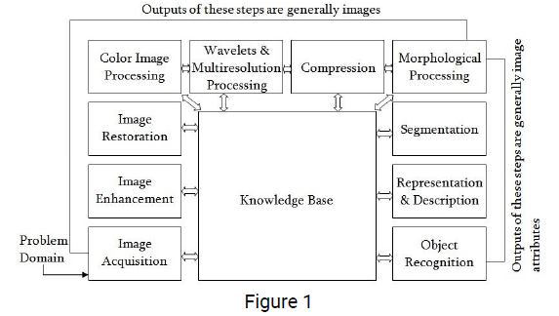

3. Image Restoration

Image restoration is an area that also deals with improving the appearance of an image. However, unlike enhancement, which is subjective, image restoration is objective, in the sense that restoration techniques tend to be based on mathematical or probabilistic models of image degradation.

enter image description here

4. Color Image Processing

Color image processing is an area that has been gaining its importance because of the significant increase in the use of digital images over the Internet. This may include color modeling and processing in a digital domain etc.

5. Wavelets and Multiresolution Processing

Wavelets are the foundation for representing images in various degrees of resolution. Images subdivision successively into smaller regions for data compression and for pyramidal representation.

6. Compression

Compression deals with techniques for reducing the storage required to save an image or the bandwidth to transmit it. Particularly in the uses of internet it is very much necessary to compress data.

7. Morphological Processing

Morphological processing deals with tools for extracting image components that are useful in the representation and description of shape.

8. Segmentation

Segmentation procedures partition an image into its constituent parts or objects. In general, autonomous segmentation is one of the most difficult tasks in digital image processing. A rugged segmentation procedure brings the process a long way toward successful solution of imaging problems that require objects to be identified individually.

9. Representation and Description

Representation and description almost always follow the output of a segmentation stage, which usually is raw pixel data, constituting either the boundary of a region or all the points in the region itself. Choosing a representation is only part of the solution for transforming raw data into a form suitable for subsequent computer processing. Description deals with extracting attributes that result in some quantitative information of interest or are basic for differentiating one class of objects from another.

10. Object recognition

Recognition is the process that assigns a label, such as, “vehicle” to an object based on its descriptors.

11. Knowledge Base:

Knowledge may be as simple as detailing regions of an image where the information of interest is known to be located, thus limiting the search that has to be conducted in seeking that information. The knowledge base also can be quite complex, such as an interrelated list of all major possible defects in a materials inspection problem or an image database containing high-resolution satellite images of a region in connection with change-detection applications. reporting processing actions, and applying similar treatments to adequate control images.

* Discuss the real life applications of IP.

Important applications of image processing in the field of science and technology include :-

1. computer vision
2. remote sensing
3. feature extraction
4. face detection
5. forecasting
6. optical character recognition
7. fingerprint detection
8. optical sorting
9. argument reality
10. microscope imaging
11. lane departure caution system
12. Non-photorealistic representation
13. medical image processing
14. morphological imaging

Conclusion:

In this case study I was able to learn about signals and its various types. We studied about DSP and its applications. I also learned about IP, need for IP and its real-world applications. I also learned about the phases involved in image processing.